AI ASSISTED CODING

NAME: SHARIKHA IMTIAZ KHAN

ROLLNO:2403A52368

TASK1: write a pyhon program to generate at least 3 assert test cases for is_strong_password(password) and implement the validator function.

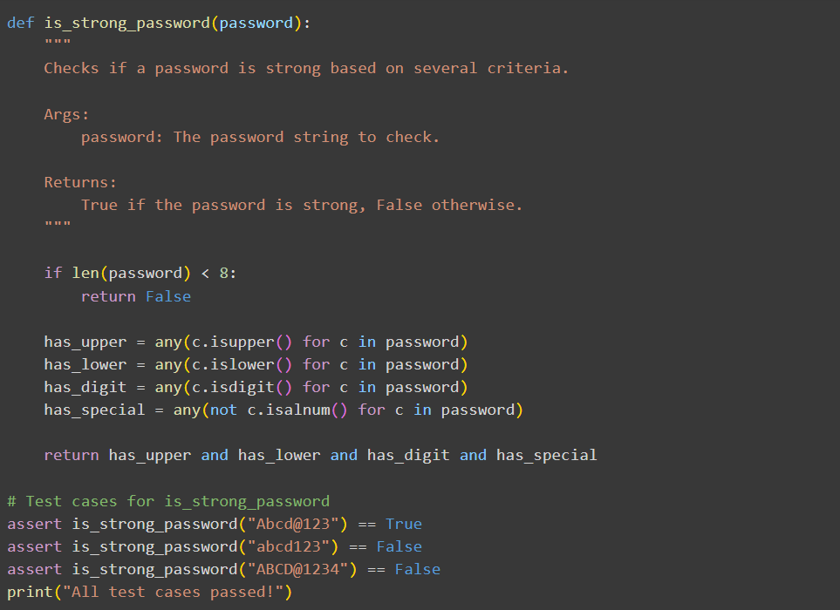

EXPLANATION:

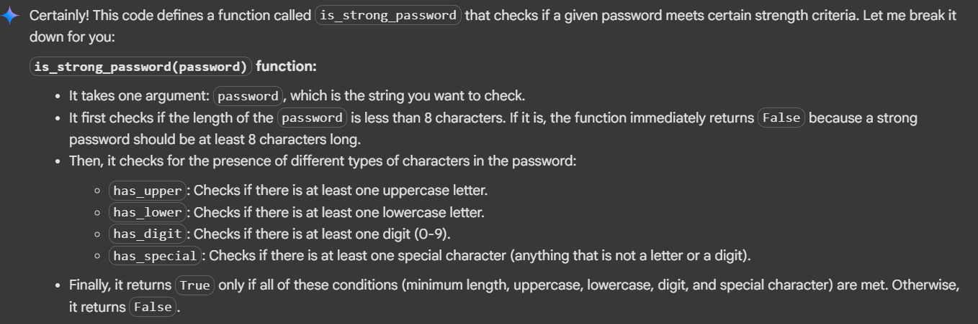

OUTPUT:



TASK2: write a python program AI to generate at least 3 assert test cases for a classify_number(n) function. Implement using loops.

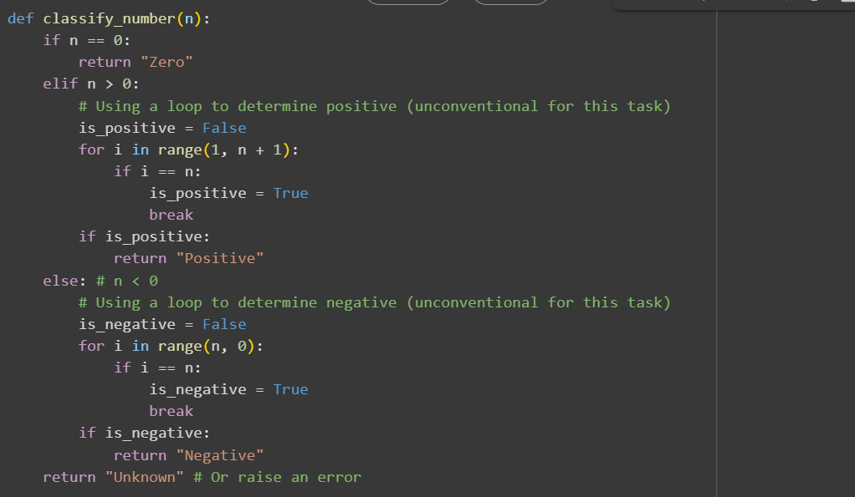

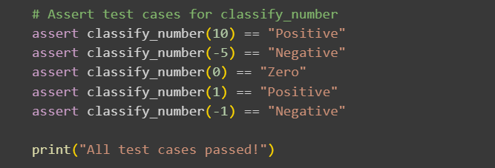

EXPLANATION:

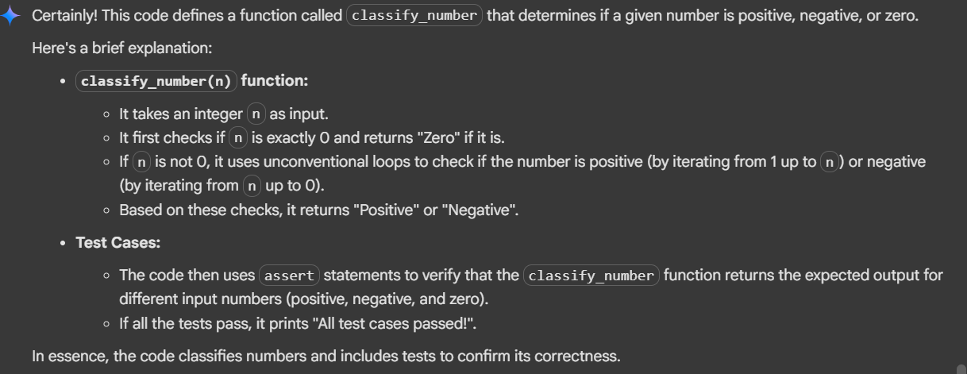

OUTPUT:



TASK3: write a python program to generate at least 3 assert test cases for is_anagram(str1, str2) and implement the function.

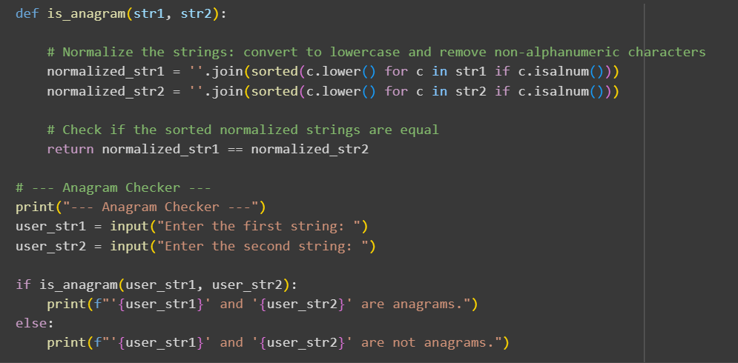

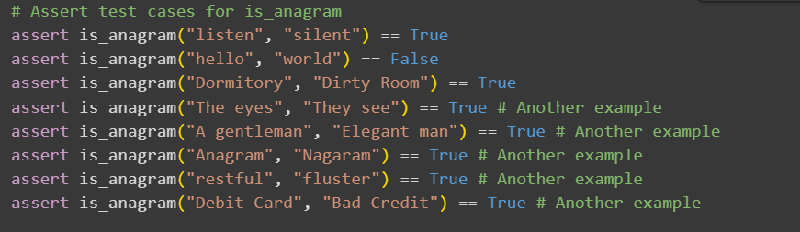

EXPLANATION:

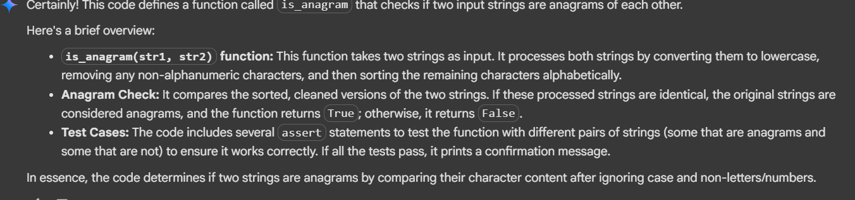

OUTPUT:

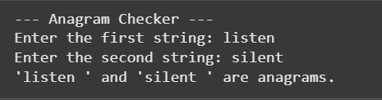



TASK4:

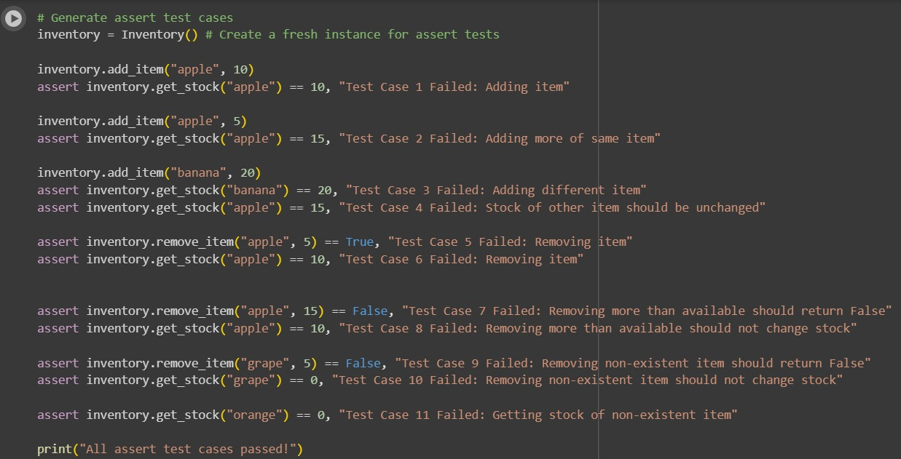

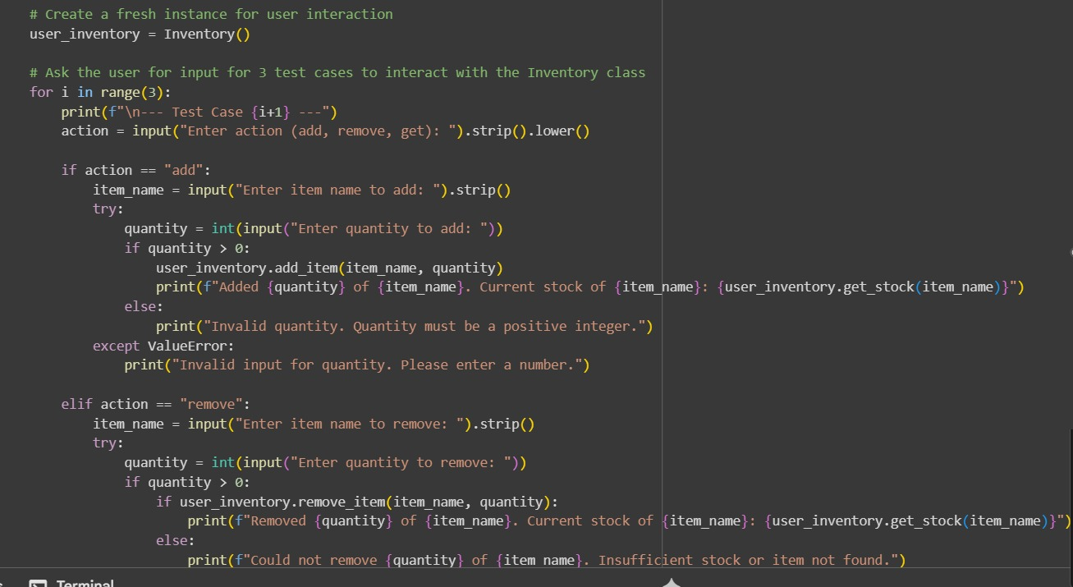

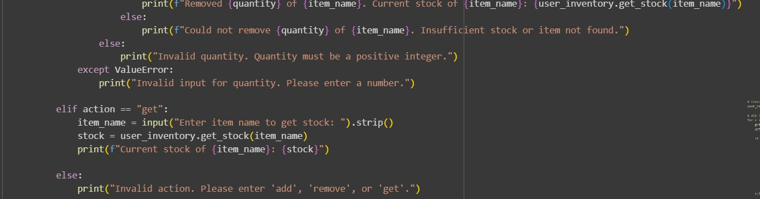

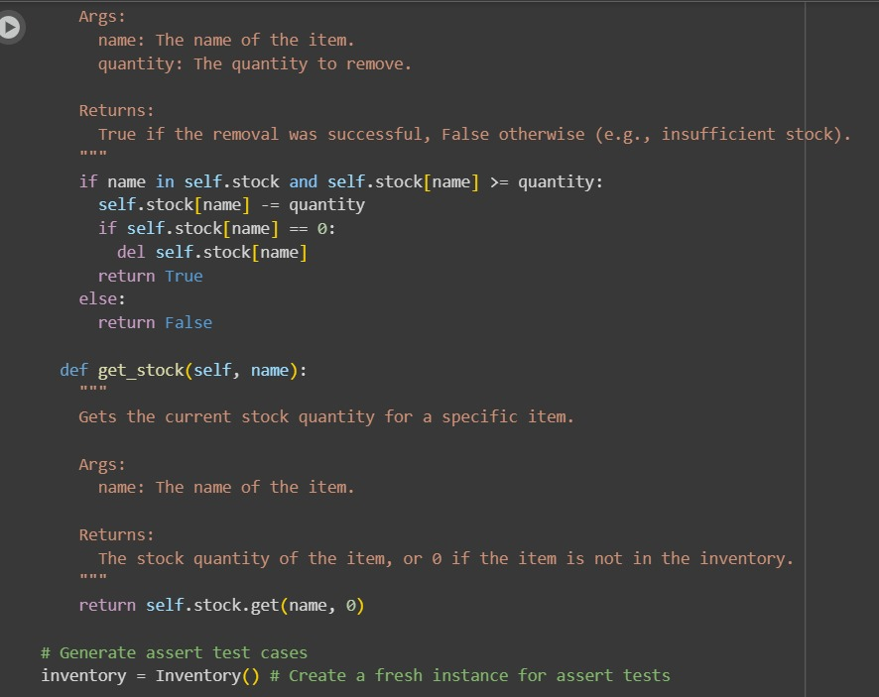

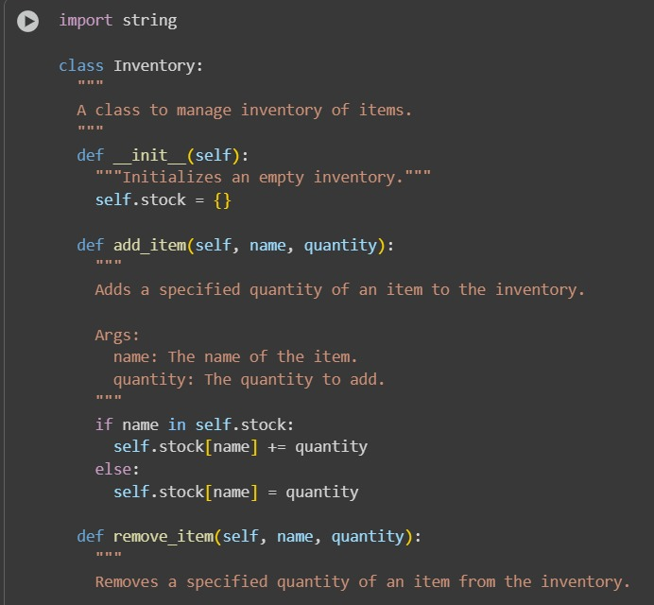

EXPLANATION:

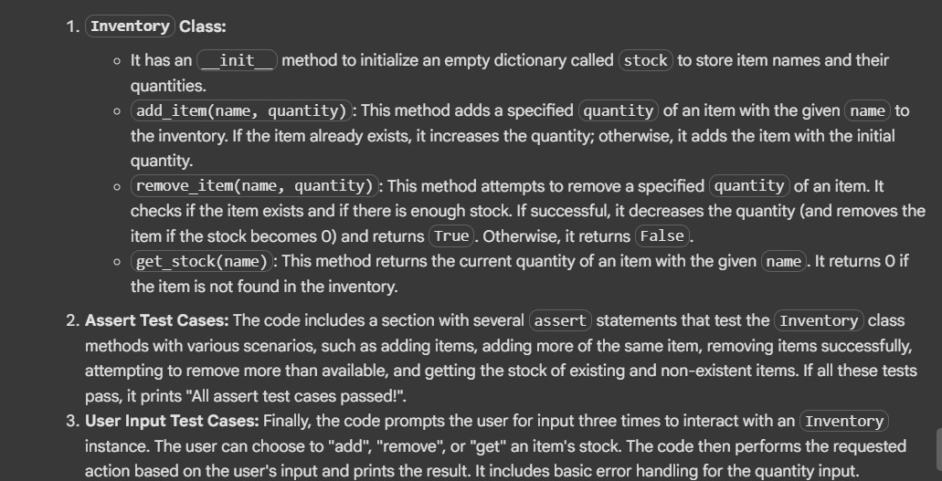

OUTPUT:

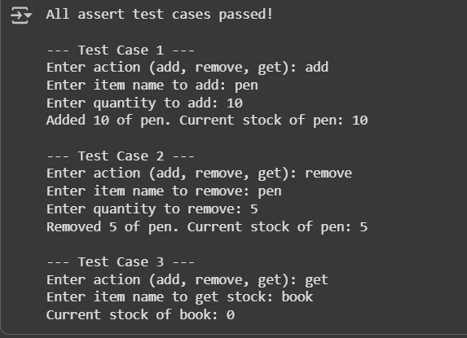

TASK5: write a python program to generate at least 3 assert test cases for validate_and_format_date(date_str) to check and convert dates.

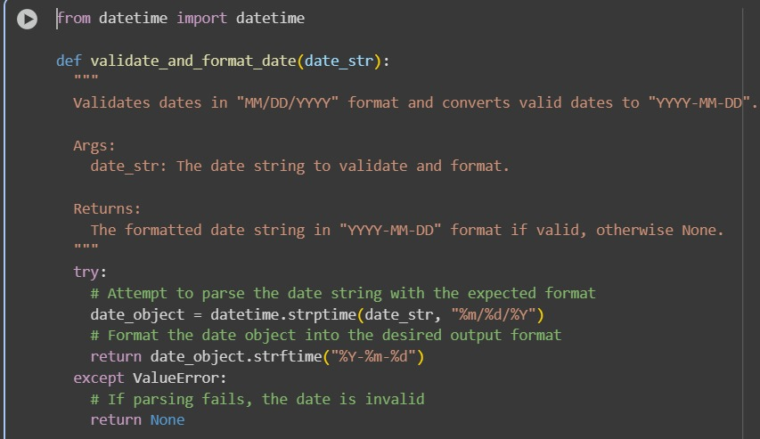

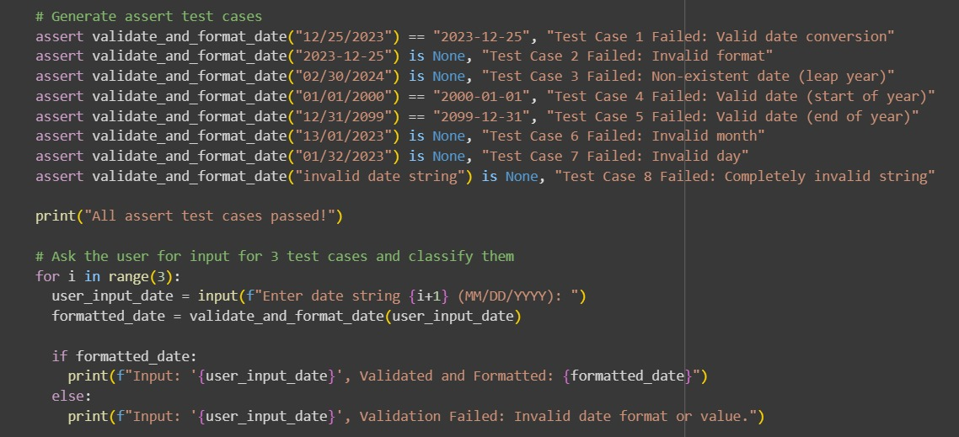

EXPLANATION:

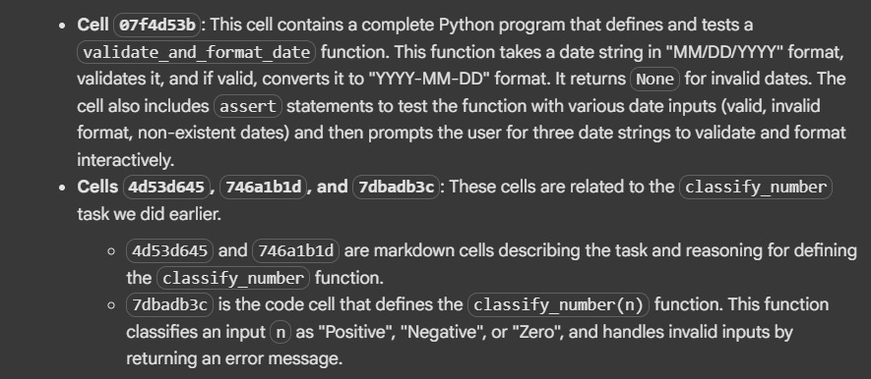

OUTPUT:

